More About Arduino Libraries and Language

The Thing about the ArduinoIDE is its Eco-System. It has been around for some while now, so there are a considerable amount of libraries that it can handle.

In this lesson, you will learn about the Libraries and how to understand them, where they ares stored on the computer and how to the Arduino language reference page.

Let us focus on one sample Library:

In The Arduino IDE menu bar:
Sketch → include Library → Library Manager and search for “LiquidCrystal”.

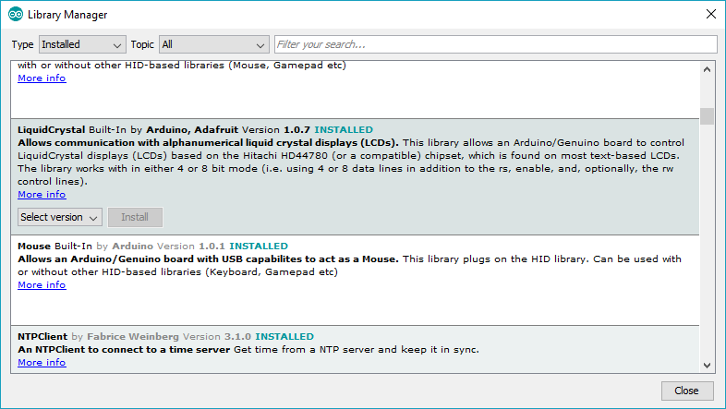

You will notice that this Library is marked as “Built in by Arduino and Adafruite”. Adafruit is a company that has many benign contributions in the Arduino and maker community.

LCD’s (Liquid Crystal Display) are a type of displays used very often in the micro controller world.
Found most often in two variations 2004 and 1602 models. That is 20 Chars x 04 Lines and 16 Chars x 02 lines. (example Vending Machines, Printers, ..etc)

Other type of displays are OLED , TFT and E-Paper displays with each has one or more library depending on the controller chip.
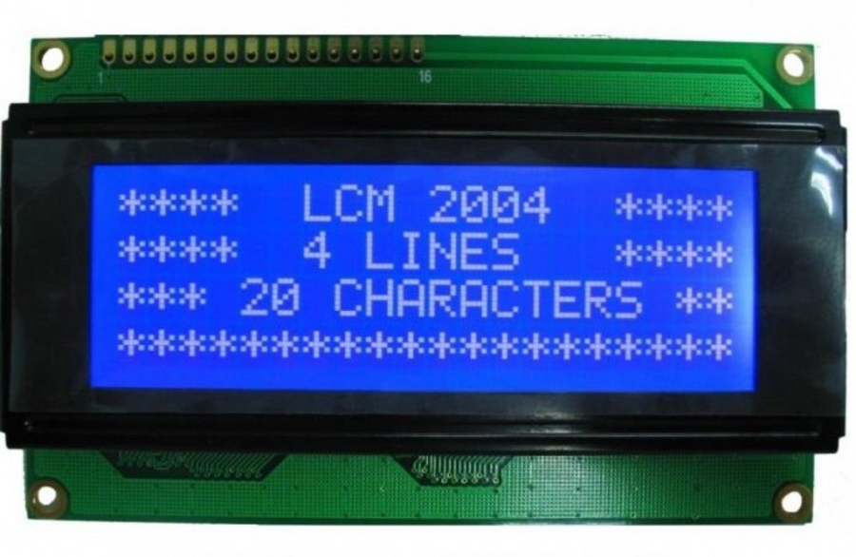 | 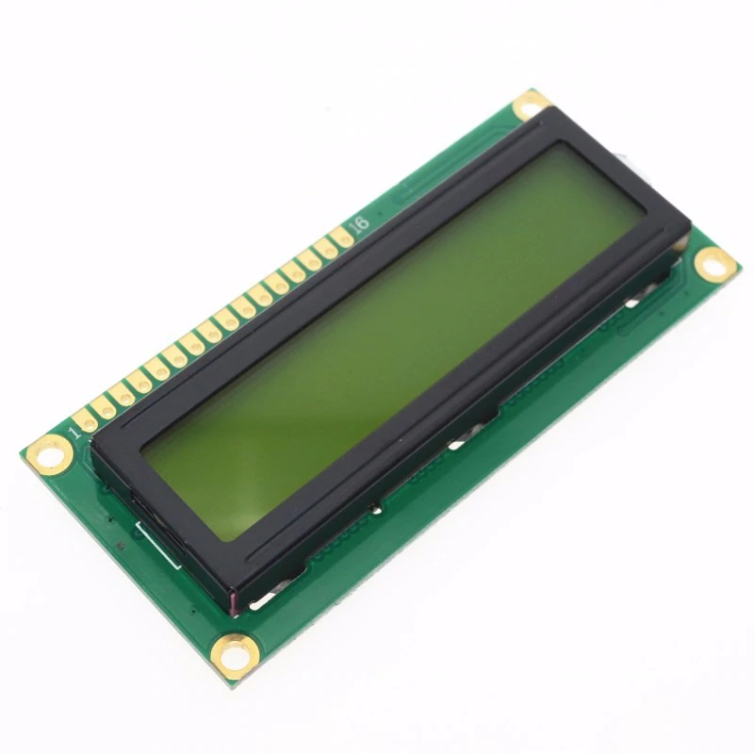
2004 | 1602

To handle these LCD’s from an ArduinoIDE compatible development board, you will definitely need to download and “include” that library in your Sketch. (We are not going to use this Library in our Dojo)

If you follow the link “More Info” it will lead you to the URL: “https://www.arduino.cc/en/Reference/LiquidCrystal“.

You will find an excerpt about the library, a list of functions and Examples to browse through.

Try browsing through these links (on the top of the page):

The first one will lead you to the Language Reference page where all the builtin Arduino functions are listed. Try to read about the following functions:
digitalRead() , digitalWrite() , pinMode() , analogRead() and analogWrite()

Unfortunately the ArduinoIDE doesn’t have the Auto-complete feature, so you will need this “Reference” bookmark a lot to get by in your programming.

Some other libraries are fetched from a github page which will “More Info” link will lead you to it.
Example “Adafruit LiquidCrystal by Adafruit”
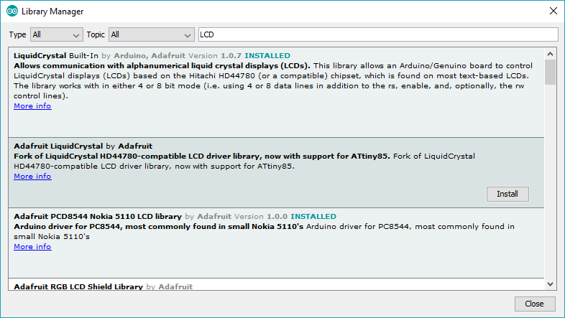
Usually; as a Maker, you browse the github page for this library looking through the “src” folder “.hpp” or *.h” files to get an overview of the library’s objects, functions and properties.
Also with each library there is an “examples” folder which shows up immediately in the ArduinoIDE once you decide to install that library.
File → Examples

There are multiple places where Arduino Libraries are stored on your computer:

<user Home folder>\Arduino\libraries (for user downloaded libraries)
<user Home folder>\AppData\Local\Arduino15\packages\esp8266\hardware\esp8266\2.5.0\libraries
…

You could unzip whatever library you download or create in the first folder and restart the ArduinoIDE to compile it and prepare it for your next usage.
The more you install libraries in the first folder the more time your ArduinoIDE will take to start up.

